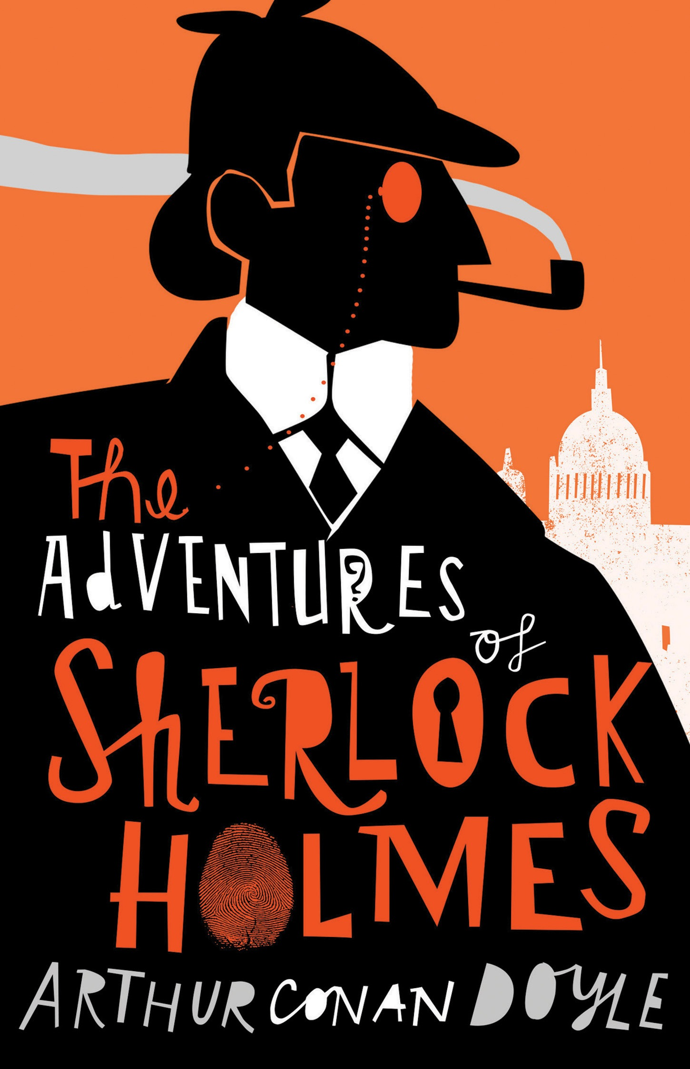

1. Title of the novel you analyzed  
   - The Adventures of Sherlock Holmes by Arthur Conan Doyle
2. Total number of words in the novel  
   - Total no. of words = 107880
3. Total number of unique words in the novel  
   - Total no. of unique words = 10122
4. 20 most frequent words in the novel including the number of times they were used

the--5411

I--2944

and--2862

of--2732

to--2719

a--2578

in--1737

that--1638

was--1386

it--1253

you--1232

he--1146

is--1125

his--1102

have--907

my--905

with--847

had--821

as—779  
which--767

1. 20 most INTERESTING frequent words in the novel including the number of times they were used

not--628

upon--464

Holmes--431

It--414

The--346

'--339

He--307

into--275

Mr--268

You--249

And--189

am--185

But--178

shall--170

There--157

door--136

Then--129

matter--118

We—114  
heard--112

1. 20 least frequent words in the novel including the number of times they were used

frowning--1

instep--1

antagonist;--1

shooting--1

abrupt--1

Folk--1

crisply--1

Gang--1

Eventually--1

gloomy--1

how----1

perspired--1

spreading--1

investment--1

scratch--1

require--1

tallow--1

incites--1

neatness—1  
Game—1

1. From Step 3, a specific word you found that had an interesting pattern usage through the book. Include the word and it’s frequency of usage for each chapter in the novel. Write a one sentence summary about why it’s pattern was worth noting.

Holmes

46 - 49 - 46 - 43 - 25 - 27 - 35 - 51 - 12 - 33 - 22 - 40 -

Sherlock

10 - 10 - 7 - 10 - 10 - 10 - 10 - 9 - 5 - 6 - 4 - 4 -  
  
The author uses Last name of Sherlock Holmes much more than the First name. The trend seems to get more marked as the chapter progresses towards the end.

1. An interesting quote from the book and the chapter it’s found in. If you don’t know what quote to choose, try Googling for quotes from the book: ie “Quotes from Harry Potter”, and chose your favorite one from the list.

Quote = My whole examination served to turn my conjecture into a certainty

Chapter found = 10

1. The randomly generated sentence from your generateSentence() method  
   - The rest is much ado to return to look rather a matter drop a mining camp had staggered and brought before very thoroughly. It looks very good purpose 30,000 pounds; and Stripes." "Dr. Becher's." "Can I ejaculated after a technical character, an out-house, but recover the minds for how many. But to-day that graver issues that reason to Horsham, I spend the church, and vouching for whoso snatches a questioning you." That bears upon their place? There would make out who may both the appointment this crowd to write from whence it anyhow, so secluded, after we might suit.